Html

Html develops the overall structure of the webpage

Css gives it design /styling

Js decides the overall logic behind the structure

Generally, when develop a website we name the file with index.html so that it becomes easy for computer to understand what is the first page

In html when we wish to feed some content in a website we do it by adding it into a container

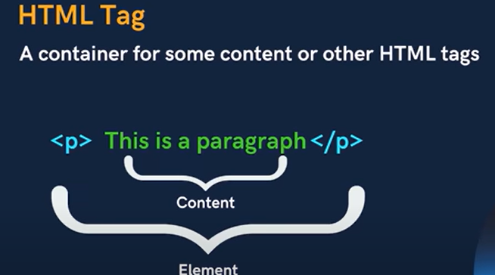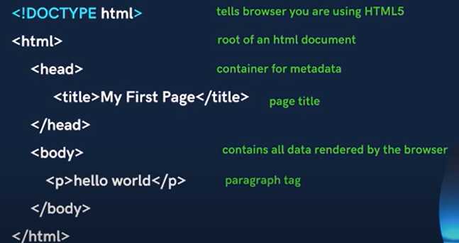

Doctype html tells the browser that this file is of html type and thus browser converts the file into a webpage

Html tag is the root container / larges container which has all other tags in website

Head tag is for meta data that is all data that is not to be presented

It is used to make page responsive and we would see it further

Body is the actual content that is visible over the page

How to add comments



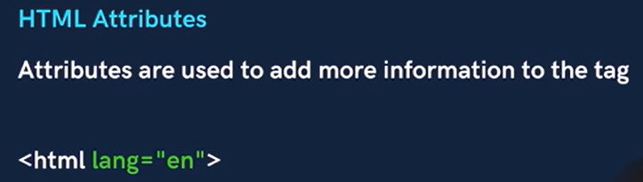

Lang=en defines that our language for html file is English

Where as we can decide many attributes like width height etc eg for button

Heading

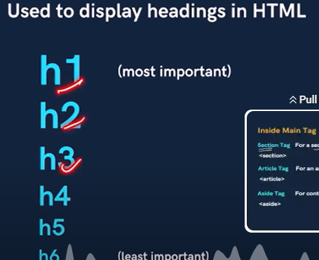

This is to show importance of a particular contents

We cannot randomly assign heading tag as when google rates our website it does It based on these headings

Paragraph tags



For multi line content

Anchor tag

Used to add links



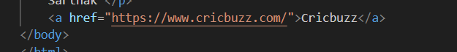

This can help us to jump from one html page to other



Go will open the next webpage

Break tag

Acts as a separation btw two tags

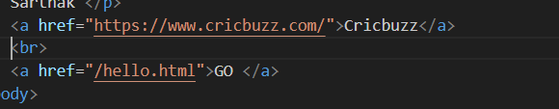



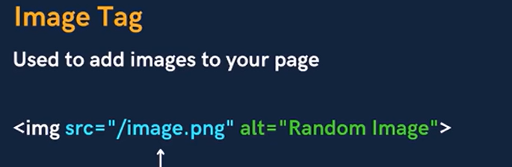



If by chance there is some error in the link then the image wont print

So we use alt tag

Alt is the alternate that would be printed instead of the image



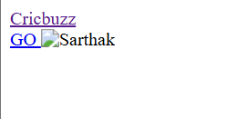

This often happens when there is error in server

Now u can save u image in the same file as of ur html file and then paste its address

Even u can set the image attribues

But always set either height or width

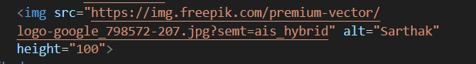

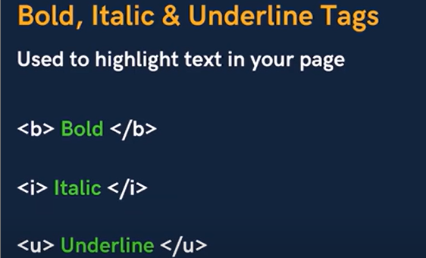

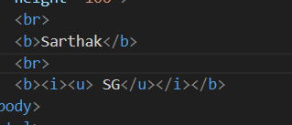



We change its boldness in css

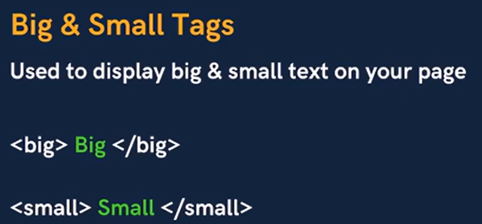



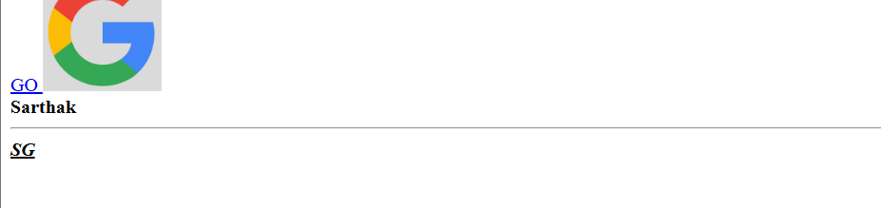

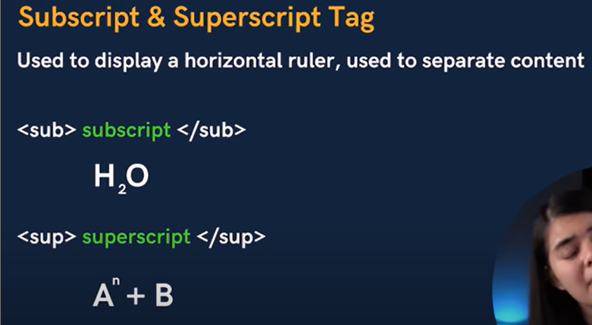





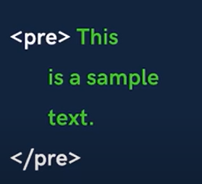

Suppose u need some extra spaces and lines in u webpage

But whatever u do in ur html code it would be ignored

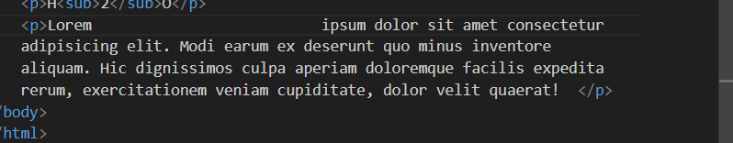

This space would be ignored

Thus we use pre tag

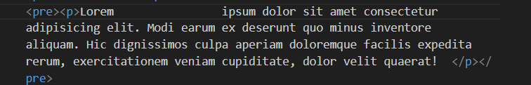



Page layout techniques



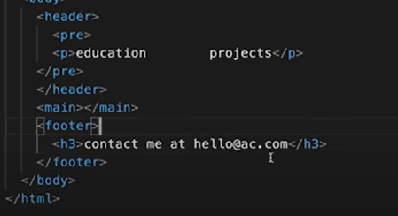

Tags to be written under main tag

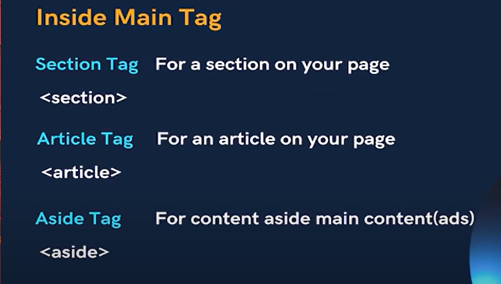

Suppose u make a section like this

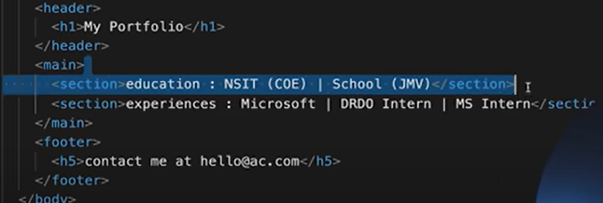

To separate sections from each other

//do I again

Suppose when u use ahref it opens the page on same page as that of ur website

But if u feel to open it on next tab

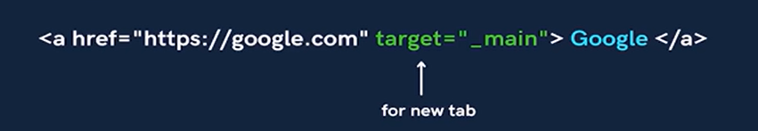

Opens on new page

To use as a clickable image

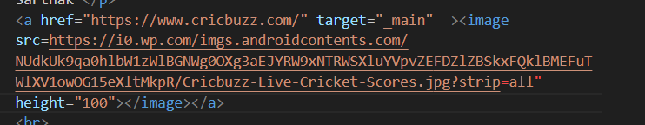



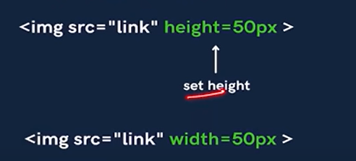

Div tag

Generally whatever the content u drop on ur website it exists within the container

So div is a container for this html element

There is as such no work performed by it

It is a block element that is it takes complete width as that of the website size

Generally, whenever u add a heading/image/ paragraph then it takes only that much space as that it requires

But div takes the complete space

So if suppose u change the color of a div then for entire block of div is changed

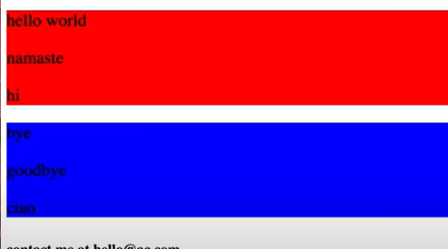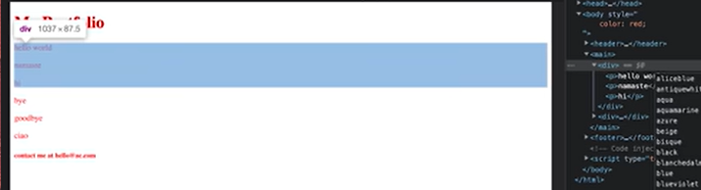

It takes the complete space

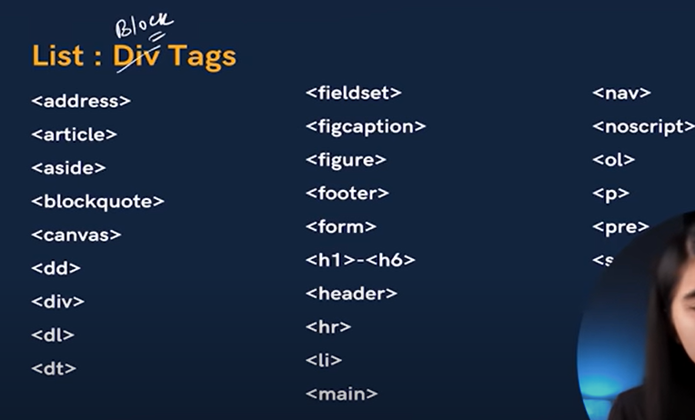

There are some important block elements



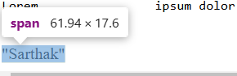



Some inline elements

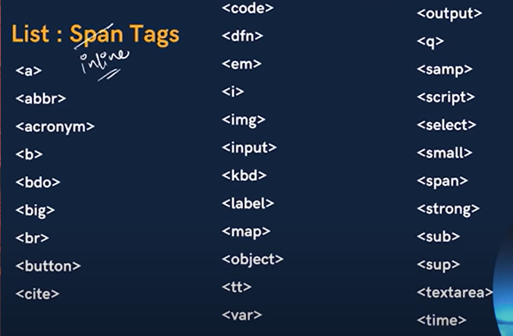

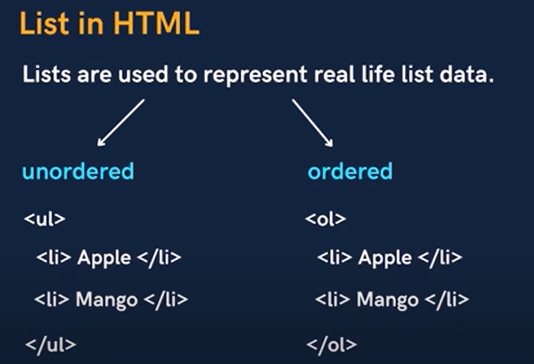

Unordered lists are the lists that are lists that are by bullet buttons

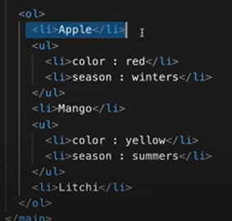

Note***

Weather u want to change the icons of the lists then u can do it

Search for it in google

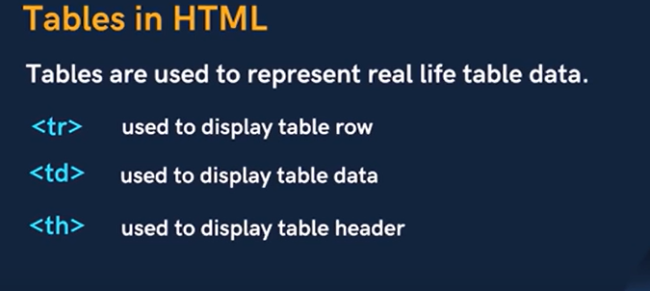

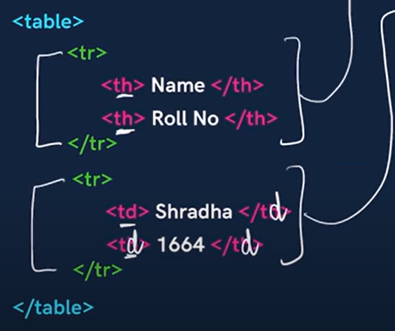

Th is for a header and td is for all rows of data

Captions in tables

Captions are the title for a table

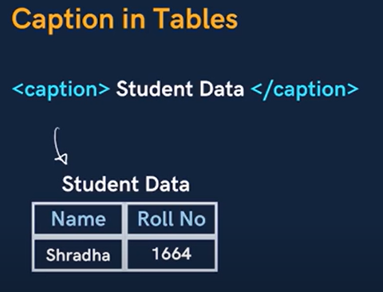

Col span

If suppose u want a common table head and use <th> tag then it will take left alignment

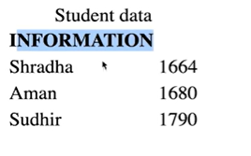

So using colspan the header can take the space of the no. of columns u mention

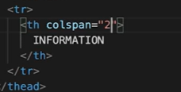

Forms in html





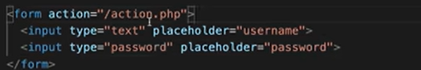

Suppose u create a form and u want a textfield like jtext in java

So u use the above tags

Even u can add placeholder

If u set type as password then the entered part in shown like this



CSS

Css works on selector

Selector selects a type of tags and styling on it

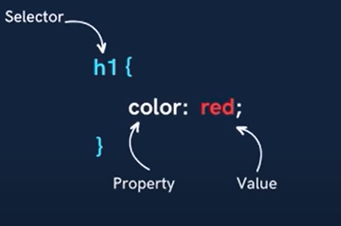

To link a css file with html file

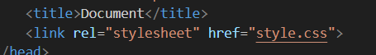

To set foreground color

These are the color of the elements like button

Imp!!!

Creating a button

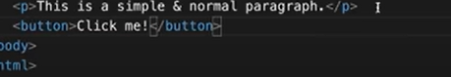

To give it a style

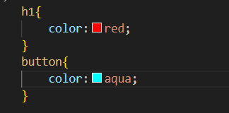

This sets the foreground

Background color

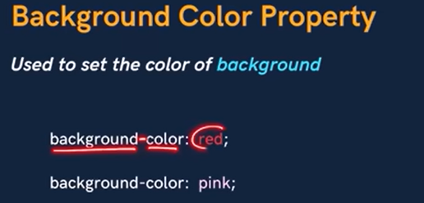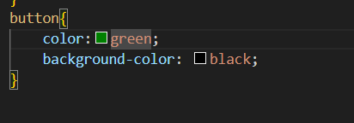

IMP!!

If we search color pallet on google then colors that go good over each other will be given

Selectors

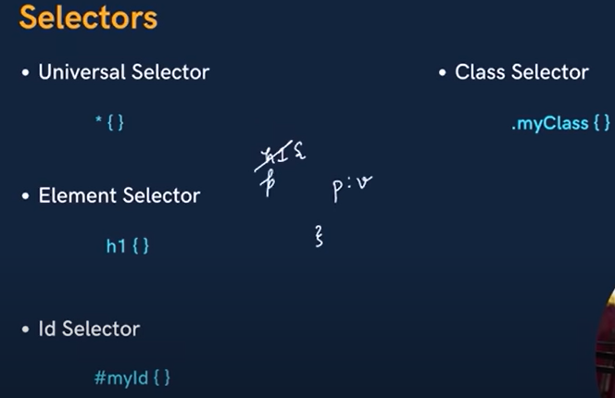

*{}-> styling applied to all the elements

Suppose u apply a color using universal selector and apply some other for suppose a heading

Still the recent is saved

Using id selector id are given in html and in css the style is given

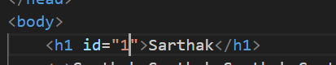

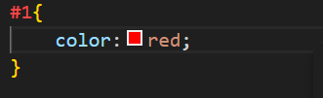

Suppose u have to give same styling u can’t give same id

Check class again

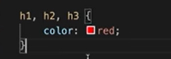

Single property can be applied to multiple element

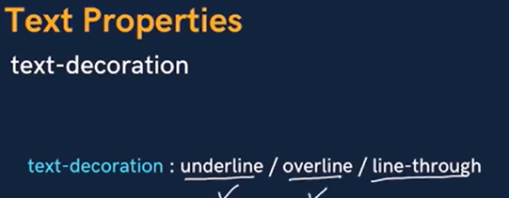

If u don’t want decoration set t as none

In mdn u can find multiple other properties

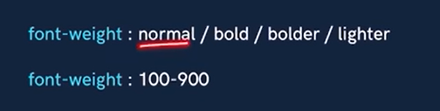

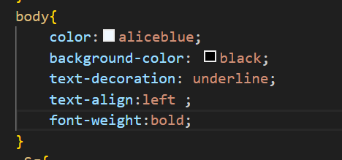



Units in CSS

There are tow types absolute and relative

Pixel(px) is most used one



U can set font size in px

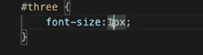

Line height

It is the space btw two lines

U can set using pixels or else set it normal

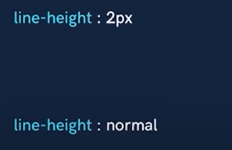

Relative units

Pixels have a fixed value for all the systems

But there are some units that have a variable value

i.e based on system to system it may differ



Percentage of child is relative to the parent

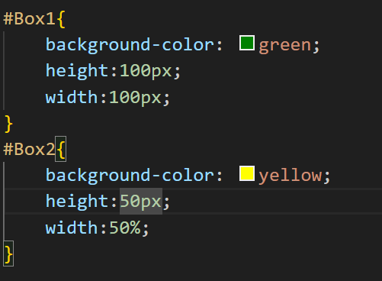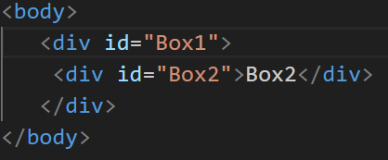

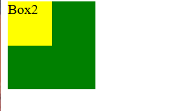

Now for box 2 ,box 1 is parent and it has 100px

So box2 will take 50% of box1 i.e50px

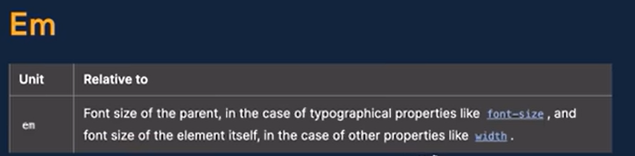

Em is relative to the property of parent

i.e parent has 100px of font size and child takes 2em i.e font size for child is 200px

suppose u set 0.5em so it will be 50px

Rem

Rem is relative to root element

Suppose content in body tag takes 50pixel and u set a text as 5rem

So its size would be 80px

Text transform



Box model in css

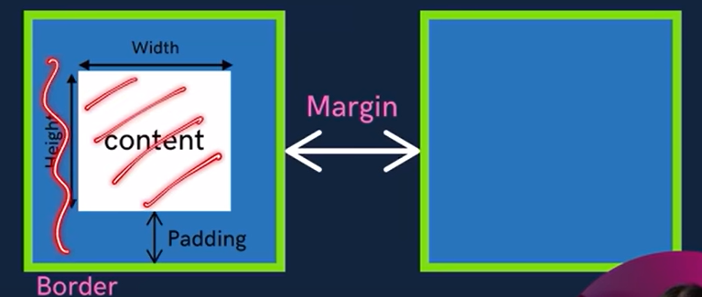

If we inspect and Hower over the content then there is some space for content some margin btw two content etc.

Normally the content gets same space as it required

But if u externally set a dimension for it like for a div if u set height as 100 then it will occupy 100 px height space

Similarly we set width

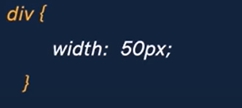

Setting border



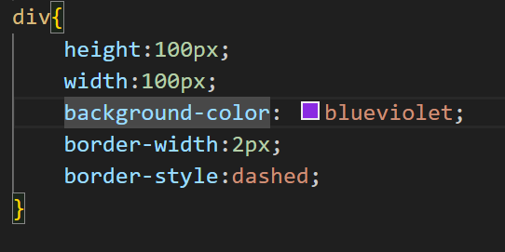

We can set all properties in a single line



Border radius

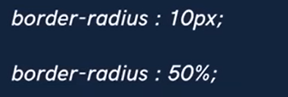

How to create a circle

Make a square div and then set border radius as 50%

How to make an ellipse

Make a rectangle of a div and then set radius as 50% or more

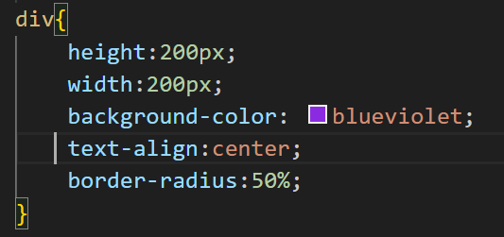

Padding

Where in the allotted space do u feel the content must be is decided by padding

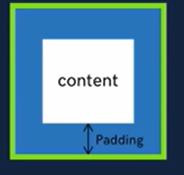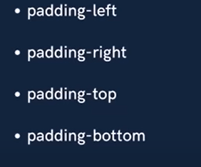

To easily set padding set it in a clockwise manner



Same for margin



Check!!!! At 2:26:44 IMP!!!!How is a navbar created

Display property

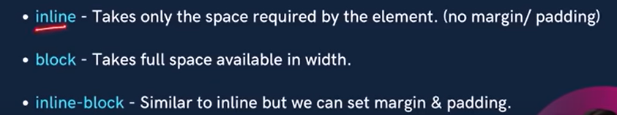

Generally button/anchor tags are inline(takes space as it require) elements

But if u set it as block(takes complete space) then it will take complete space

Eg. Heading is an block element but it can be converted into block

If u set display property as none

Then there wont be any space to the display and thus it wont be shown on website

Similarly



If u set visibility none then there is space allocated to it but no visibility

Whereas in display as none the space itself is not reserved

Alpha channel

It decides the opacity of the content

U set alpha value along with RGB value

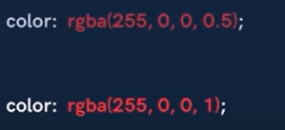

It ranges btw 0-1

Position

Flex model

This can be excellent to make navbars (suppose there are multiple links then u can place it at equal distance within itself easily

We understand flex using two perpendicular axis i.e main axis and cross axis

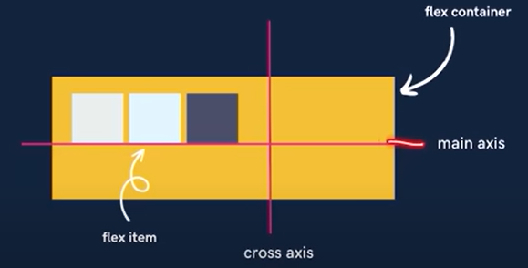

Main axis /cross axis can be horizontal or vertical but bth axis must be perpendicular

To get all flex properties u set display:flex to a container

Flex box follows flex box direction

Is suppose u create multiple divs

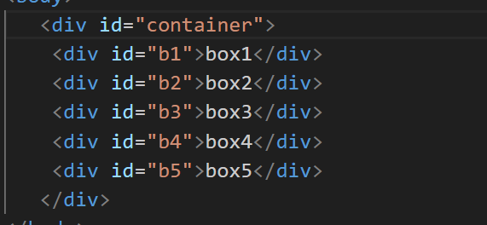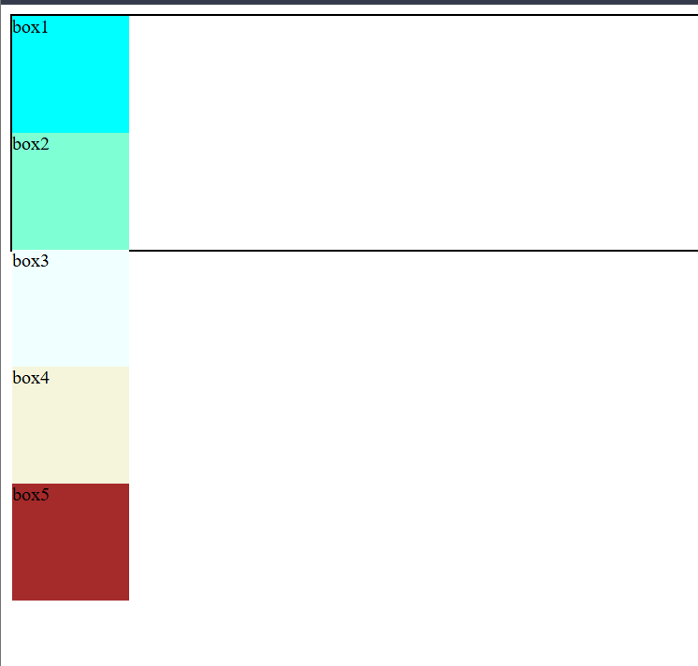

It will appear like this

But as soon as u set flex as display it sets the default flex direction

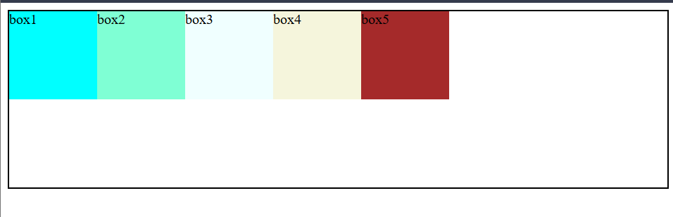

i.e the first element comes first

and serially arranged

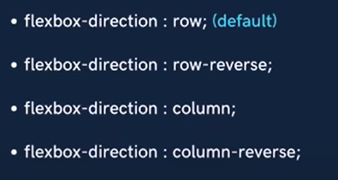

This default i.e row flex box direction

If u set row reverse then in same series it will take reverse direction

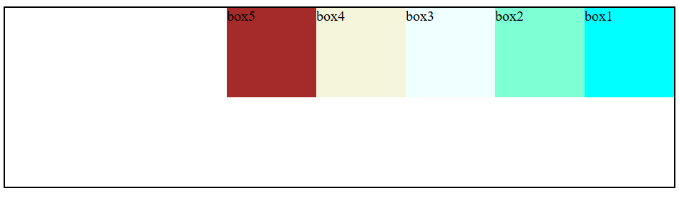

If due to size it goes beyond all element would adjust itself within permitted space

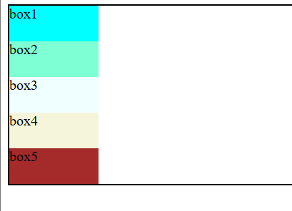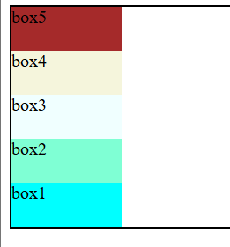

Though box size was too much but all adjusted equally

This adjustment is only until the content allows

Flex properties:

Justify content

Suppose within a flexbox u set a flex-direction as row then all elements are arranged from left to right

Thus the main axis moves from left to right

So if u set justify content as flex start then there is no change

But if u set it to flex end then all elements in same sequence shift to the end of flex box

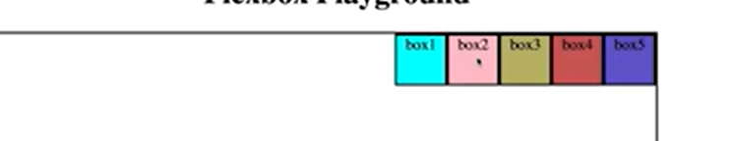



If u set space around then the space is spread around the box

If space evenly then the space is spread evenly



Understand this!!!

Media Queries

How to create a responsive website

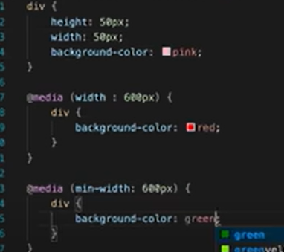

Suppose u have created a website and while changing the size of the page various properties must continue to change

Like suppose there is a div with pink color and u have set that as soon as website size reaches 600px the color must change to red the above tag is written

U can even use range of values

Like if the min width is 600 px and u go beyond it the color must change

Transition

There may be multiple events that may occur with the content on the page

Thus the content makes transition from one state to other

Thus how he transition must be made i.e after making a click or hovering over it the color must change or the transition must happen after a delay etc is done in transitions

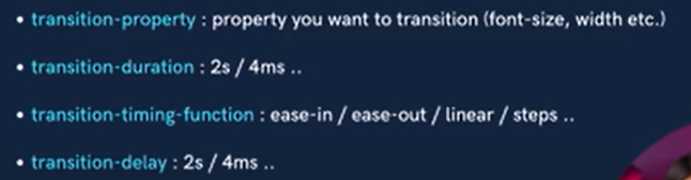

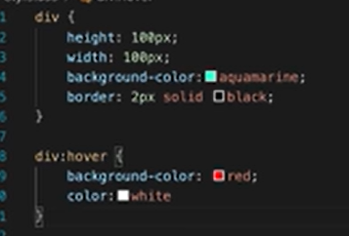

There may be multiple events like active(i.e until when the click is active over the content) or hover etc

All other types we can explore in mdn references

Transition duration is the time for which the transition should occur and delay is the time after which the transition must occur after the event has occurred

JS

Events in Js

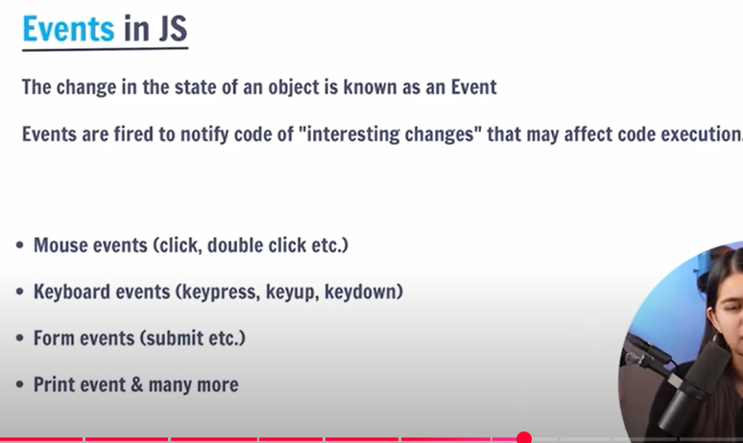

We may get different events in mdn references

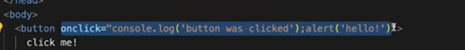

So the no. of times u click the button on the console the content would be printed

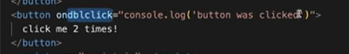

This was for event when the button is clicked two times

Similarly u can keep events for different elemets also

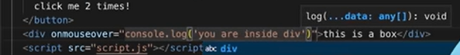

There are multiple events mostly due to the change in the work done by the mouse or the keyboard

Now as soon as ur mouse is over the div the printing will be performed

This is inline way of event handling

But better than doing this in the html part u can do it in js file itself

But priority is mor for the event by the js part

Just u need to give an id



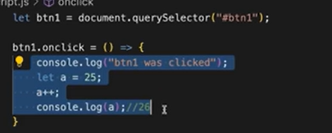

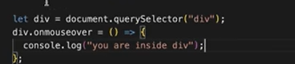

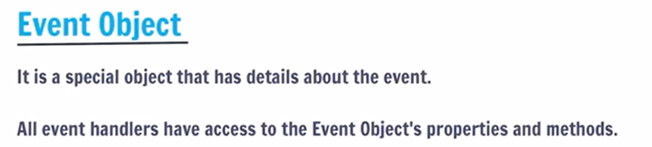

This object remembers all the properties of the events

Like event type or event target etc

If u try and print the object

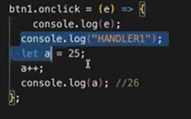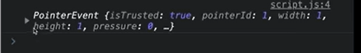

So all properties get printed

The important properties are

Target: the element over whom the event occur

Type: what is the type of the event

clientX/Y: it is the vertical or horizontal position where the event occurs

Php

Variables

It is dynamically typed language i.e no need to define the type of variable

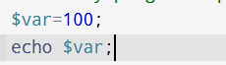

Variable is declared by adding a $before name

There Is never a space given by php

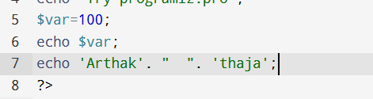

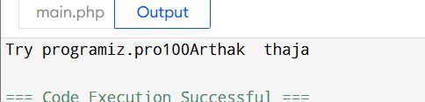

Whenever u need new line

Data types

***

Var_dump

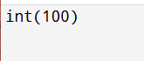

This gives the type of the variable and the size

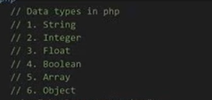

Thus whenever u do this u get the type of data type

Conditional statement

Even conditional statement is same



Array

This is how u define an array and access an element



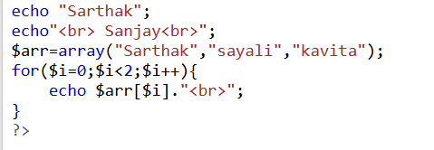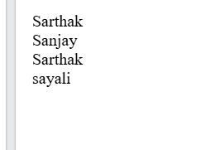

Important methods



Gives size of array

Loops

